## **http://bettersoils.soilwater.com.au/module5/images/5_6_cartoon.gifINFILTRATION TEST**

## **Does your soil sip, or slump and spill?**

A well structured soil can drink in rainfall. A poorly structured soil will tend to slump blocking soil pores and cause ponding and water to run-off.

Even a high quality soil will eventually break down after several storms. The aim is to improve soil structure to maximise infiltration and minimize run-off. An Infiltration test is an economical tool to compare areas on your farm, and track the affects of your management programme.

### **You will need:**

* 20cm long plastic downpipe about 10-15cm diameter (cut on an angle to make it easier to insert) or an old coffee tin with the bottom cut off. Mark the inside of the tin at 10cm then 2.5cm marks up the side of the tin.
* 10cm long knife
* 2 litres of rain or distilled water
* 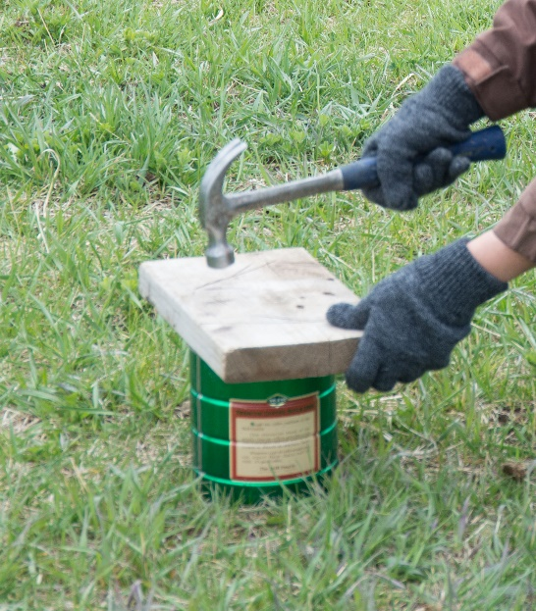Hand sledge and wood board or block
* Stop watch, ruler, note book and pen

## **In the field**

**Step One:** Clear the sampling area of surface residue, etc. If the site is covered with vegetation, trim it as close to the soil surface as possible. Make sure the site is dry.

**Step Two:** Press the sharpened end of the pipe into the soil until it is 100mm deep into the soil or lay a wooden board over the top of the can. Strike the board with the hammer until the can is driven into the ground to the 10cm mark.

If the soil contains rock fragments and the can cannot be inserted to the appropriate depth, gently push the can into the soil until it hits a rock fragment.

If the soil is very dry and compacted, then use the knife to cut a slit into the soil for the cylinder, whilst disturbing the soil as little as possible.

**Step Three:** Insert a ruler and add 2.5cm water at a time.

**Step four:** Note the time and pour the water quickly into the pipe. When the last bit of water disappears check the time again and see how many seconds/ minutes it took for 2.5cm of water to soak in.

**Step five. Repeat Infiltration Test:**

Using the same can, perform Steps 3 and 4 with a second and then third 2.5cm of water. Record the number of minutes elapsed for the second infiltration measurement.

All of the tests should be conducted consecutively.

If you conduct multiple tests and they produce the same result, this result is most likely an accurate estimate of the saturated infiltration rate.

**The infiltration rate**

The infiltration rate measured in mm/minute, is the depth of water the measuring cup puts into the pipe divided by the time it took to soak in. Values of 1 or 2 mm/minute are okay, smaller infiltration rates than this means that large storms will cause runoff.

## **Considerations**

## If the soil is saturated, the infiltration test will not work, so wait a few more days for the soil to dry out.

If you capture an additional 25mm rain, it can mean 1/2 ton/ha extra in yield.

If the soil surface is uneven inside the ring, count the time until half of the surface is exposed and just glistening:

The moisture content of the soil will affect the rate of infiltration; therefore, two or three infiltration tests are usually performed (if soil is dry). The first inch of water wets the soil, and the second inch gives a better estimate of the infiltration rate of the soil.